E | W | C | O | P | P | E | R | D | K | L | L | J | S | M
L | I | G | H | T | N | I | N | G | R | L | K | T | A | I
E | R | E | S | I | S | T | O | R | L | Y | L | R | B | N
C | E | W | W | T | E | W | Y | U |  | O | G | H | N | S
T | P | A | C | E | R | T | I | U | V | A | B | N | M | U
R | A | M | I | P | S | V | W | T | I | S | C | E | L | L
O | R | P | R | O | T | O | N | D | C | Z | O | X | V | A
N | A | E | C | S | A | L | H | P | L | H | M | L | C | T
E | L | R | U | I | T | T | T | M | K | X | P | O | A | O
R | L | E | I | T | I | A | R | Y | J | C | O | W |  | R
T | E | W | T | I | C | G | R | H | H | V | N | Q | U | I
Y | L | S | X | V | V | E | E | A | M | M | E | T | E | R
C | U | R | R | E | N | T | D | F | G | A | N | A | D | S
U | I | E | L | E | C | T | R | O | L | Y | T | E | S | A
E | L | E | C | T | R | O | N | S | D | S | S | F | G | C
Pearson Science 9 Chapter 6.1 & 6.2 Revision

- Positively charged part of an atom
- Part of an atom that moves during the flow of electricity
- Measures current
- Electricity caused by a build up of charge
- When electrons are removed what charge remains
- Unit current is measured in
- What happens when a charge builds up in the atmosphere?
- Measurement of the amount of energy supplied
- Electricity caused by the movement of a charge
- Path electrons travel through
- A voltmeter measures ___________
- The parts of a circuit
- Short hand version of a circuit: a circuit ______
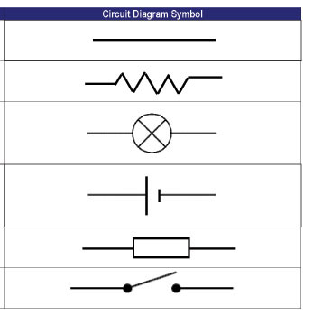
- What do each of the following symbols stand for?
- Type of cell with electrodes in a liquid
- Type of cell with one electrode wrapped in another
- A solution that conducts electricity
- What type of energy to photovoltaic cells convert?
- Unit to measure resistance
- Materials that do not conduct electrocity
- Used for most household wires
- What needs to move for electricity to flow?
- Should voltmeters be connected in series or parallel?



